Corporate & Social Responsibility Policy

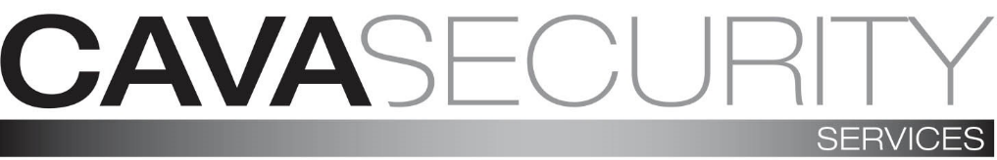

General

We recognise that we must incorporate our business values and operations to meet the expectations of our stakeholders. They include customers, employees, regulators, suppliers, the community and the environment.
We recognise that our social, economic and environmental responsibilities to these stakeholders are integral to our business. We aim to demonstrate these responsibilities through our actions and within our corporate policies.
We take seriously all feedback that we receive from our stakeholders and, where possible, maintain open dialogue to ensure that we fulfil the requirements outlined within this policy.
We will be open and honest in communicating our strategies, targets, performance and governance to our stakeholders in our continual commitment to sustainable development.
The Managing Director is responsible for the implementation of this policy and will make the necessary resources available to realise our corporate responsibilities. The responsibility for our performance to this policy rests with all employees throughout the company.

Policy Focus:
- We shall strive to improve our environmental performance through implementation of our Environmental policy.
- We shall ensure a high level of business performance while minimising and effectively managing risk.
- We shall encourage dialogue with consumers for mutual benefit.
- We will register and resolve customer complaints in accordance with our Complaints procedure.
- We shall support and encourage our employees to help local community organisations and activities in our region.
- We shall operate in-line with our equal opportunities policy for all present and potential future employees.

- We will offer our employees clear and fair terms of employment and provide resources to enable their continual personal development.
- We shall provide safeguards to ensure that all employees are treated with respect and without sexual, physical or mental harassment.
- We shall provide, and strive to maintain, a clean, healthy and safe working environment.
- We shall uphold the values of honesty and fairness in our relationships with stakeholders.
- Our contracts will clearly set out the agreed terms, conditions and the basis of our relationship.
- We will operate in a way that safeguards against unfair business practices.
- We shall encourage suppliers and contractors to adopt responsible business policies and practices for mutual benefit.

