Anti-Slavery Policy

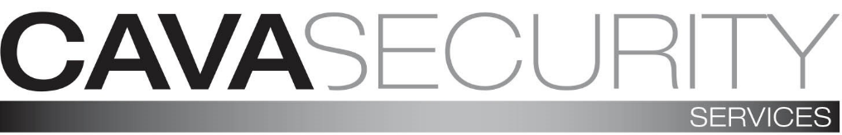

General

Modern slavery is a crime and a violation of fundamental human rights. It takes various forms, such as slavery, servitude, forced and compulsory labour and human trafficking, all of which have in common the deprivation of a person's liberty by another in order to exploit them for personal or commercial gain. We have a zero-tolerance approach to modern slavery and we are committed to acting ethically and with integrity in all our business dealings and relationships and to implementing and enforcing effective systems and controls to ensure modern slavery is not taking place anywhere in our own business or in any of our supply chains.
We are also committed to ensuring there is transparency in our own business and in our approach to tackling modern slavery throughout our supply chains, consistent with our disclosure obligations under the Modern Slavery Act 2015. We expect the same high standards from all of our contractors, suppliers and other business partners, and as part of our contracting processes, we include specific prohibitions against the use of forced, compulsory or trafficked labour, or anyone held in slavery or servitude, whether adults or children, and we expect that our suppliers will hold their own suppliers to the same high standards.
This policy applies to all persons working for us or on our behalf in any capacity, including employees at all levels, directors, security officers, agency workers, external consultants and business partners. The Managing Director has overall responsibility for ensuring this policy complies with our legal and ethical obligations, and that all those under our control comply with it.
HR Support has primary and day-to-day responsibility for implementing this policy, monitoring its use and effectiveness, dealing with any queries about it, and auditing internal control systems and procedures to ensure they are effective in countering modern slavery.
Management at all levels are responsible for ensuring those reporting to them understand and comply with this policy and are given adequate and regular training on it and the issue of modern slavery in supply chains.

Signed: Position: Managing Director

Name: Richard Payton Date:- 13th March 2019

Obligations;
All directors, security officers, agency workers, external consultants and business partners must ensure that they read on induction from in the handbook, understand and comply with this policy.
The prevention, detection and reporting of modern slavery in any part of our business or supply chains is the responsibility of all those working for us or under our control. You are required to avoid any activity that might lead to, or suggest, a breach of this policy. You must notify your manager or the compliance as soon as possible if you believe or suspect that a conflict with this policy has occurred, or may occur in the future. You are encouraged to raise concerns about any issue or suspicion of modern slavery in any parts of our business or supply chains of any supplier tier at the earliest possible stage. If you believe or suspect a breach of this policy has occurred or that it may occur, you must notify your manager or report it in accordance with our Whistle blowing Policy as soon as possible.
If you are unsure about whether a particular act, the treatment of workers more generally, or their working conditions within any tier of our supply chains constitutes any of the various forms of modern slavery, raise it with your manager or the compliance officer. We aim to encourage openness and will support anyone who raises genuine concerns in good faith under this policy, even if they turn out to be mistaken. We are committed to ensuring no one suffers any detrimental treatment as a result of reporting in good faith their suspicion that modern slavery of whatever form is or may be taking place in any part of our own business or in any of our supply chains. Detrimental treatment includes dismissal, disciplinary action, threats or other unfavourable treatment connected with raising a concern. If you believe that you have suffered any such treatment, you should inform HR Support immediately. If the matter is not remedied, and you are an employee, you should raise it formally using our Grievance Procedure with the Managing Director immediately whom will raise an internal none conformance and address within an agreed acceptable timescale. Any employee who breaches this policy will face disciplinary action, which could result in dismissal for misconduct or gross misconduct. We may terminate our relationship with other individuals and organisations working on our behalf if they breach any part this policy.

